

Practices for Secure Software Report

Table of Contents
Document Revision History 3
Client 3
Instructions 3
Developer 4
1. Algorithm Cipher 4
2. Certificate Generation 4
3. Deploy Cipher 4
4. Secure Communications 4
5. Secondary Testing 4
6. Functional Testing 4
7. Summary 4
8. Industry Standard Best Practices 4

Document Revision History

Version | Date | Author | Comments
1.0 | December 13, 2025 | Hunter Goodwin

Client



Instructions

Submit this completed practices for secure software report. Replace the bracketed text with the relevant information. You must document your process for writing secure communications and refactoring code that complies with software security testing protocols.

- Respond to the steps outlined below and include your findings.
- Respond using your own words. You may also choose to include images or supporting materials. If you include them, make certain to insert them in all the relevant locations in the document.
- Refer to the Project Two Guidelines and Rubric for more detailed instructions about each section of the template.

Developer
Hunter Goodwin

Algorithm Cipher

SHA-256 is the cryptographic hash algorithm selected for this project. SHA -256 is part of the SHA-2 cryptographic hash functions, and it creates fixed-length 256-bit hash values. It was designed to be deterministic, collision-resistant, and largely unfeasible to reverse. This makes it a well-suited method of securing communications and verifying data integrity.

SHA-256 is a one-way hash function which means the original data cannot be reconstructed from the hash. This makes it ideal for checksum verification, where the goal is to confirm that transmitted data has not been altered. Furthermore, SHA-256 doesn’t rely on symmetric or asymmetric keys. It instead uses deterministic hashing and internal compression functions.

SHA-256 is widely adopted and actively maintained. It is also recommended by NIST for data integrity. It remains a secure and trusted algorithm in modern sensitive applications such as financial or government systems.

Certificate Generation
Insert a screenshot below of the CER file.

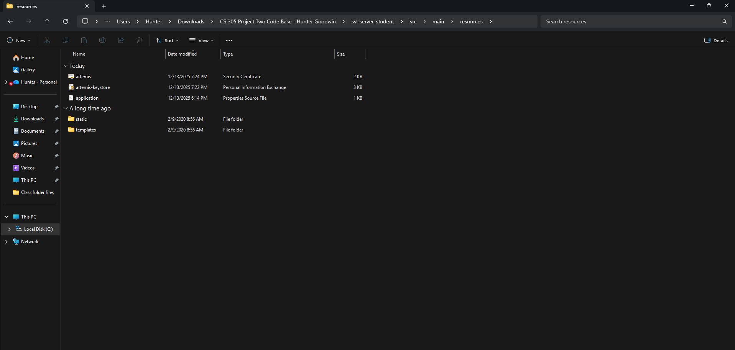

Deploy Cipher
Insert a screenshot below of the checksum verification.

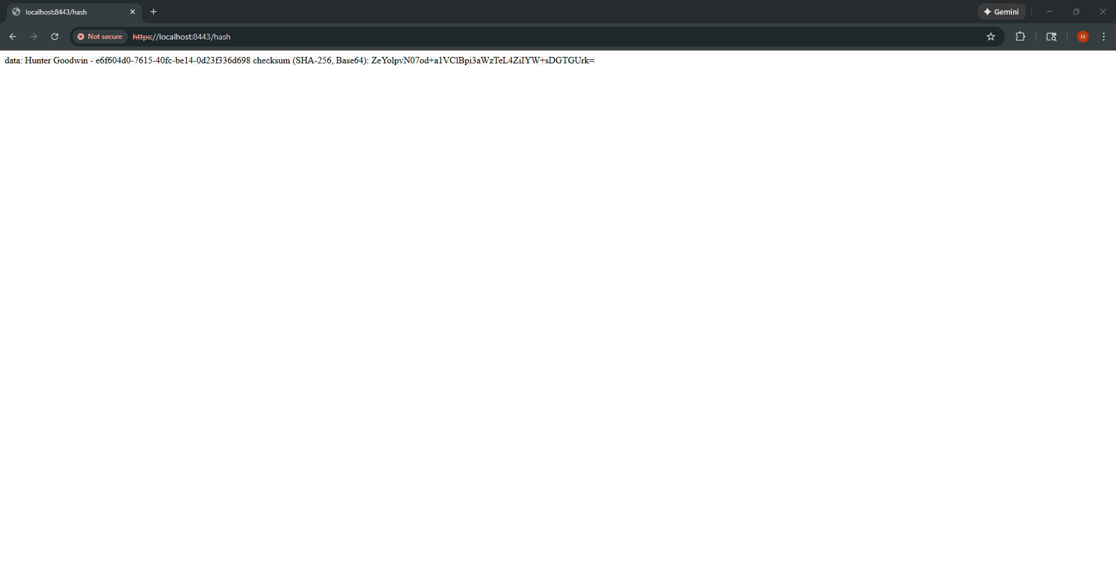

Secure Communications
Insert a screenshot below of the web browser that shows a secure webpage.

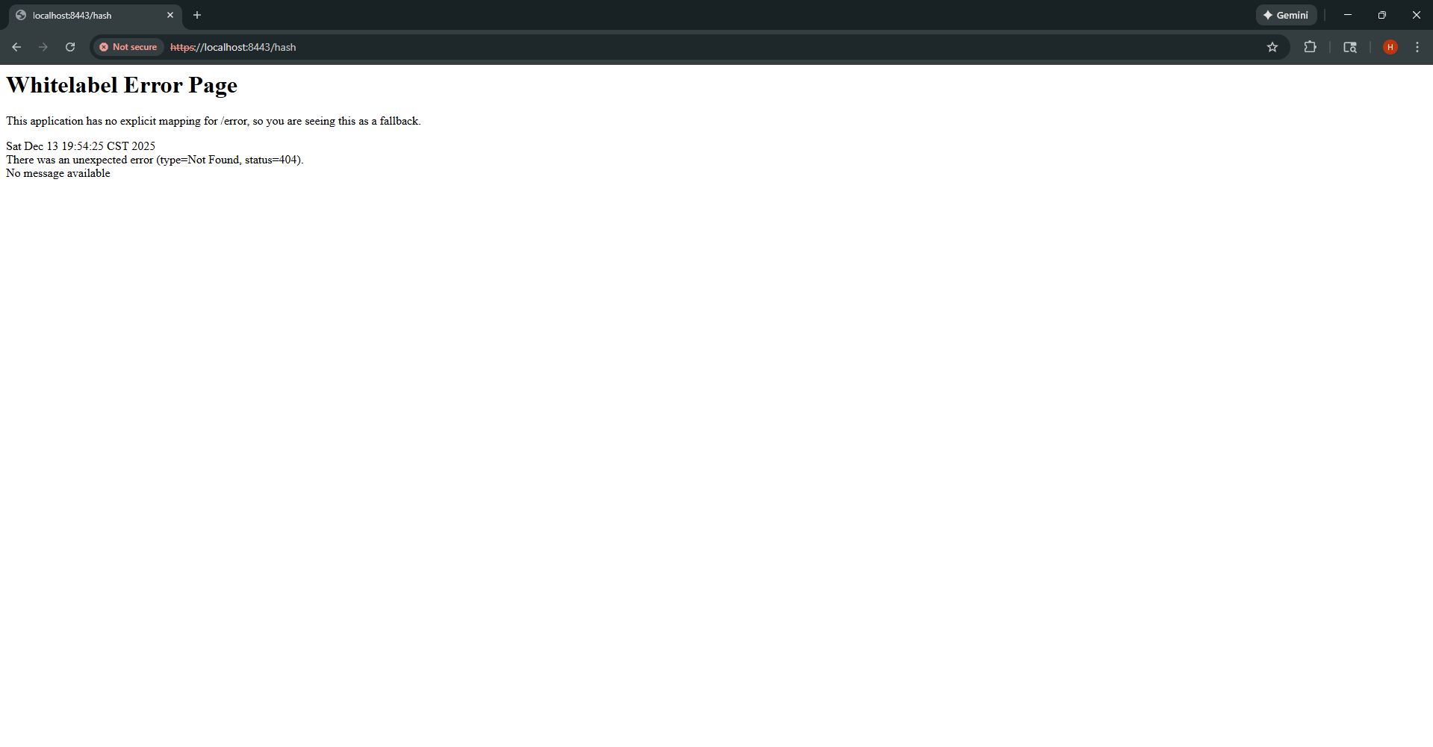


Secondary Testing
Insert screenshots below of the refactored code executed without errors and the dependency-check report.

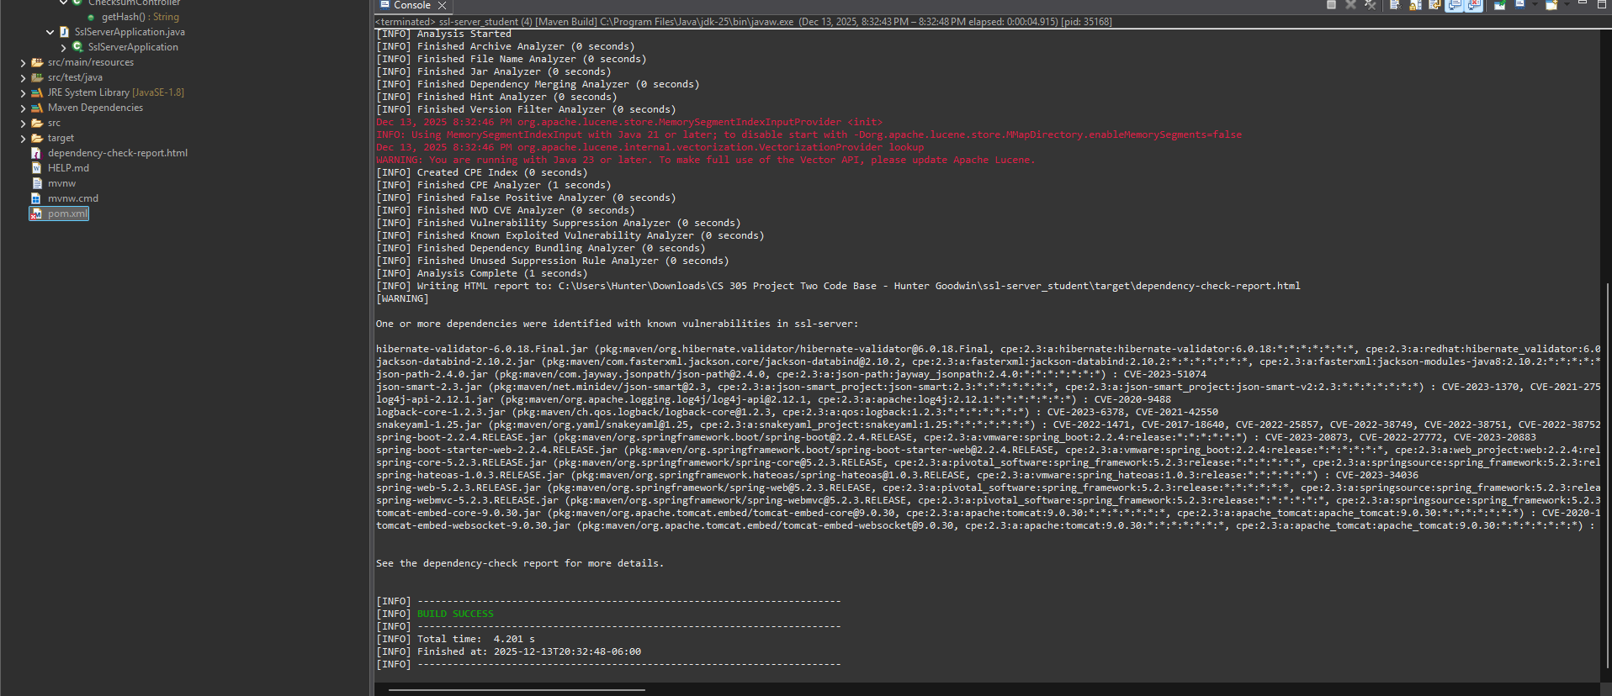
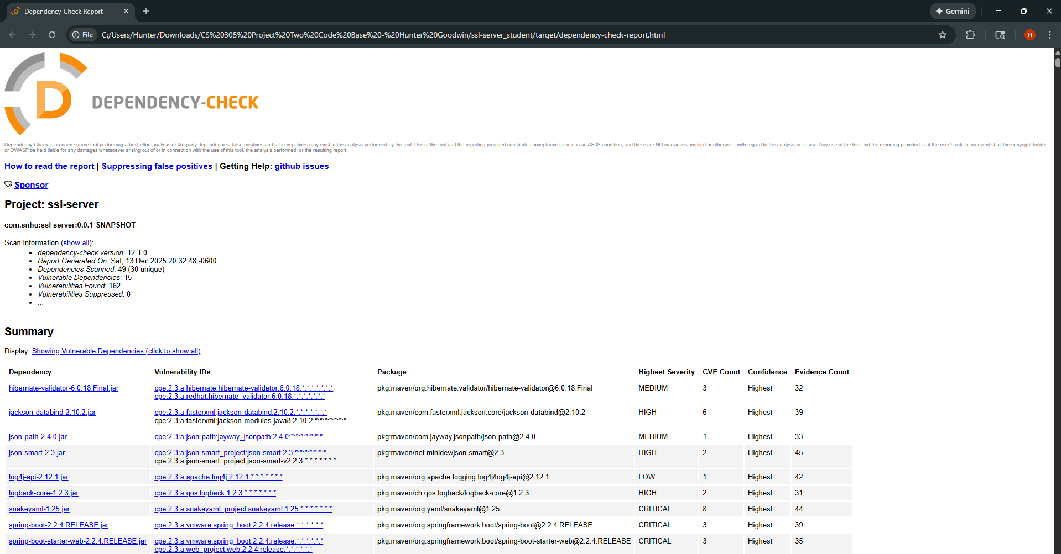

Functional Testing
Insert a screenshot below of the refactored code executed without errors.

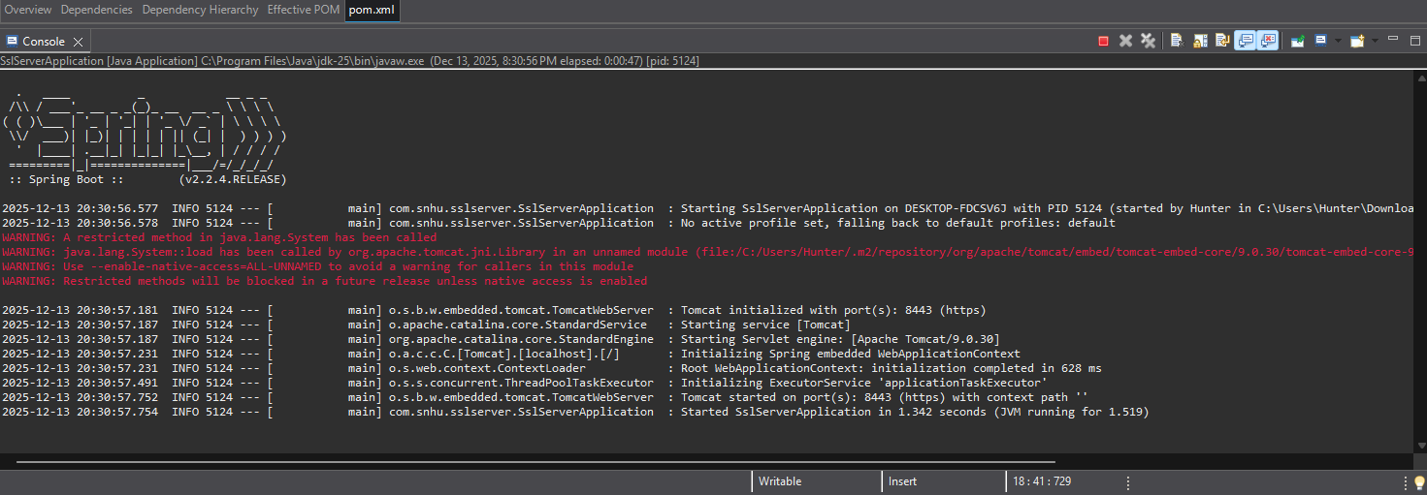

Summary

The program was refactored after a vulnerability assessment was completed. During the assessment, we discovered the need for secure communication implemented using HTTPS, data integrity using SHA-256 checksum verification, and static/functional testing. Certificate management was handled by generating a digital certificate to support TLS-based encryption. These steps combined support the vulnerability assessment lifecycle.

Industry Standard Best Practices

Industry Standards and Best Practices were applied throughout the process and alongside the application of security measures. SHA-256, a NIST-approved cryptographic algorithm, was used to ensure reliability via commonly recognized data protection mechanisms. TLS-based encryption was used to safeguard the communication of data in transit. Deprecated protocols were avoided to reduce vulnerability exposure. Automated statis testing tools such as Maven were utilized to identify and track dependency-level risks during development. Manual functional and security validation was also performed during implementations. These best practices help protect sensitive financial data at Artemis Financial and reduce the likelihood of a breach. However, security measures erode overtime and continuous maintenance and adherence to best practices are required to ensure Artemis Financials’ data remains protected.

